(Day-13 afternoon session)

1. Write a program to create a arraylist of double element and add the elements. sort the elements in descending order and print it.

//code

import java.util.*;

import java.util.Collections; public class Question1 {

public static void main(String[] args) { ArrayList<Double>list =new ArrayList<Double>(); list.add(36.50);

list.add(19.10);

list.add(58.88); System.*out*.println("before sorting:");

for(double newlist:list)

{

System.*out*.println(newlist);

}

Collections.*sort*(list,Collections.*reverseOrder*()); System.*out*.println("AFTER SORTING:");

for(double newlist:list)

{

System.*out*.println(newlist);

}

}

}

//output

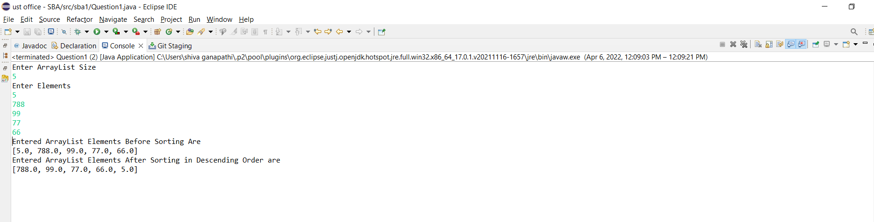

1. Create a arraylist of integers and find the sum and average of the entire list.

//code

import java.util.*; public class Question2 {

public static void main(String[] args) {

List < Integer > list = new ArrayList < Integer > (); list.add(10);

list.add(90);

list.add(30);

list.add(40);

list.add(70); list.add(100); list.add(60);

System.*out*.println("Elements in List : " + list); Integer a[] = new Integer[list.size()]; list.toArray(a);

System.*out*.print("Elements in List : ");

for (Integer obj : a) { System.*out*.print(obj + " ");

}

int sum = *sumOfArray*(a, a.length - 1); System.*out*.println();

// Print the sum returned above System.*out*.println("Sum of elements : " + sum); int avg;

avg=sum/2; System.*out*.println("Average:"+ avg);

}

public static int sumOfArray(Integer[] a, int n) { if (n == 0)

return a[n]; else

return a[n]+*sumOfArray*(a, n - 1);

}

}

**//output**

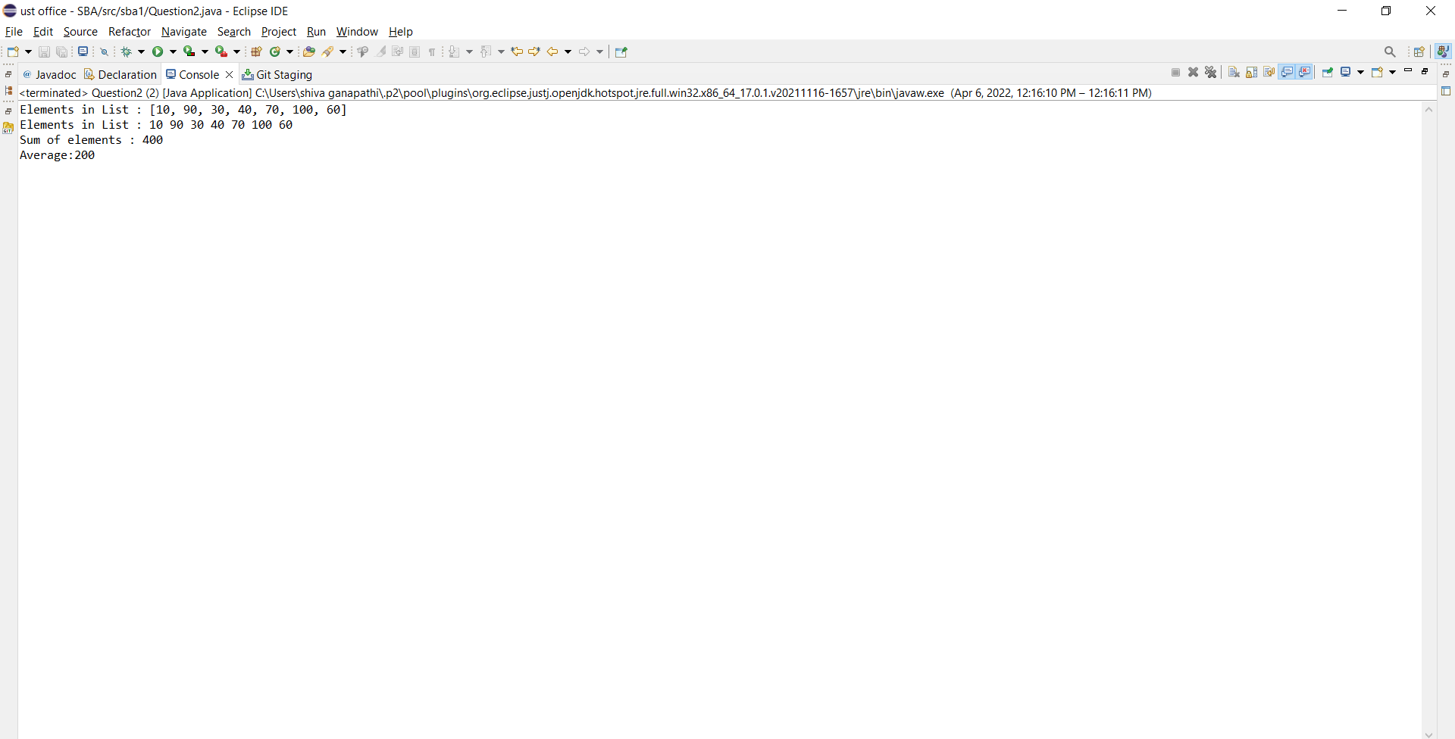

1. Create two arraylist of strings to take First_name and Last_name of the students, and print their whole name.

//code

import java.util.*; public class Question3 {

public static void main(String[] args) {

List<String> firstName = new ArrayList<String>(); List<String> lastName = new ArrayList<String>(); String string1 = "CASTRO"; firstName.add(string1);

String string2 = "JOSEPH"; firstName.add(string2);

// /////inserting last name String string3 = "ROCKY"; lastName.add(string3); String string4 = "ROBIN"; lastName.add(string4);

Iterator<String> iterator = firstName.iterator(); Iterator<String> iterator1 = lastName.iterator(); List<String> name = new ArrayList<String>();

while (iterator.hasNext()&& iterator1.hasNext() )

{

name.add(iterator.next()+" "+iterator1.next());

}

Iterator<String> iterator11 = name.iterator(); while(iterator11.hasNext())

System.*out*.println(iterator11.next());

}

}

//output

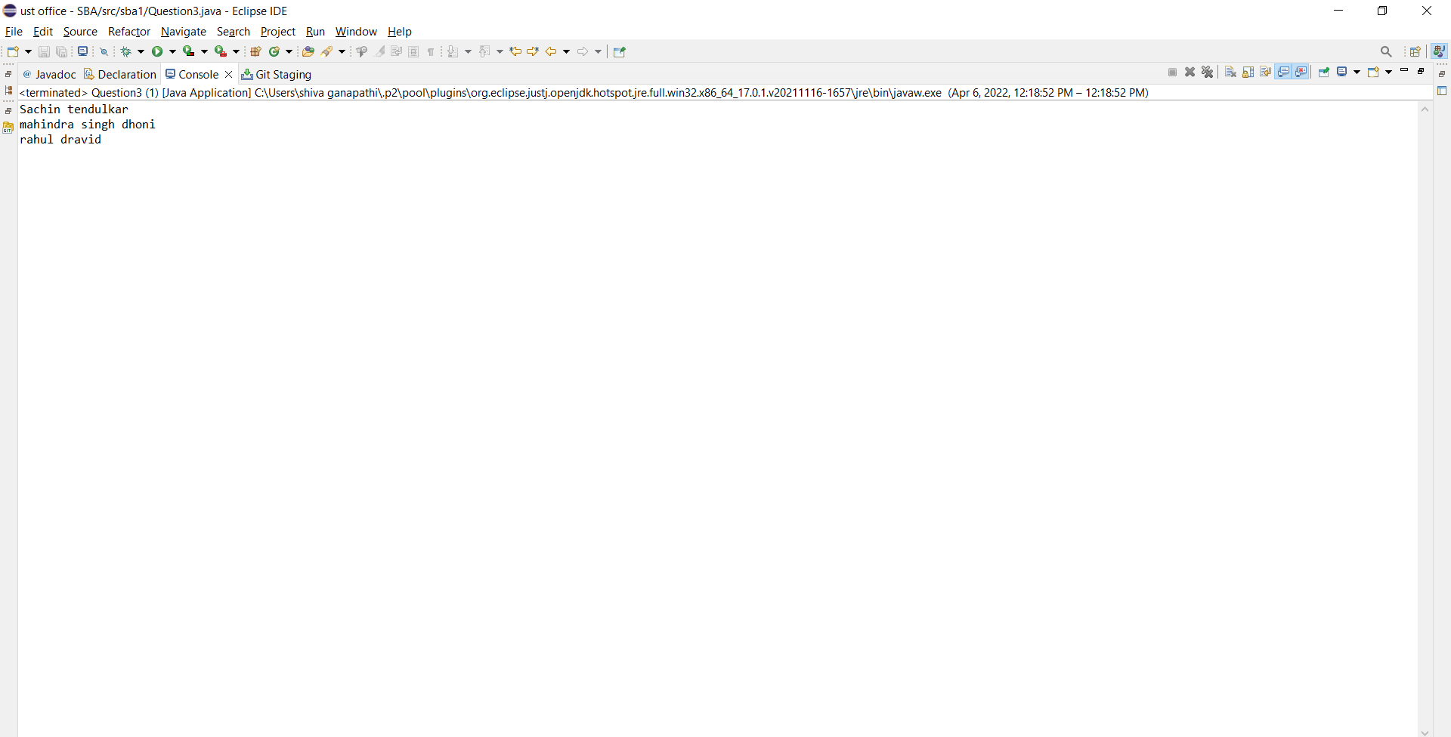

(day-8 assignment)

1. Write a program to check for the occurrence of a particular character in a string and display how many times it has occurred.

note: take the String and the character to be checked as a input from the user.

//code

import java.util.*; public class Question4 {

public static void main(String[] args) {

count");

Scanner sc=new Scanner(System.*in*); String s1;

int count =0;

System.*out*.println(" Enter the string"); s1=sc.nextLine();

//s1=s1.replace(" ","");

System.*out*.println("Enter the element to be searched with

char c = sc.next().charAt(0); for(int i=0;i<s1.length();i++)

{

if(s1.charAt(i)==c) count++;

}

System.*out*.println(" "+c+" appears "+count+" times");

}

}

//output

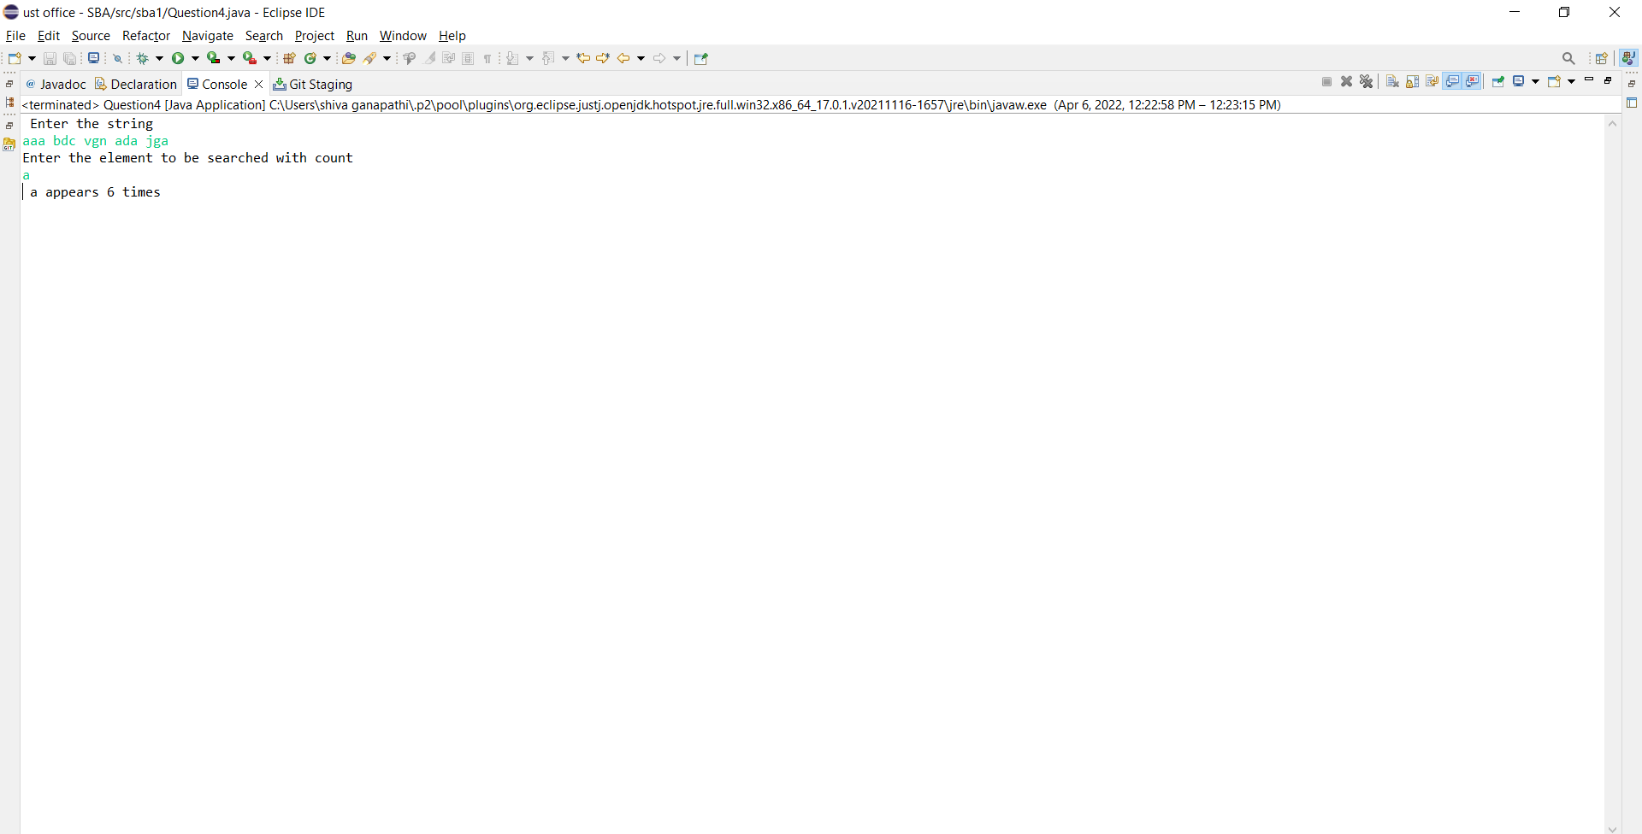

1. Write a program to take an input of a string with multiple words and convert it into a string array,

and check if every element of that array is a Palindrome.

Note: Palindrome is a word which when reversed also is the same.

//code

import java.util.Scanner; public class Question5 {

public static boolean checkpalindrome(String str)

{

int len =str.length(); for(int i=0;i<len/2;i++) {

if(str.charAt(i)!=str.charAt(len-i-1)) return false;

}

return true;

}

public static void main(String[] args) { Scanner sc=new Scanner(System.*in*);

System.*out*.println("enter the sentence"); String str=sc.nextLine();

String[] arr=str.split(" "); int n=arr.length;

for(int i=0;i<n;i++) if(Question5.*checkpalindrome*(arr[i])) {

System.*out*.println(arr[i]+" is palindrome");

}

else

System.*out*.println(arr[i]+" is not a palindrome");

}

}

//output

